MINI PROJECT

EMBEDDED SYSTEMS

ITE305

Submitted By: Submitted To:

Mukul Dev Dr. Balaji Raman

13BIT0269 ITE305 Mentor



**Embedded C program to toggle to alternate bits of port 1**

#include<stdio.h>

#include<regx51.h>

void delay(const unsigned int x)

{

unsigned int i,j;

for(i=0;i<x;i++)

for(j=0;j<1275;j++){}

}

int main()

{

while(1)

{

P0=0xaa;

delay(600);

P0=0x55;

delay(600);

}

}

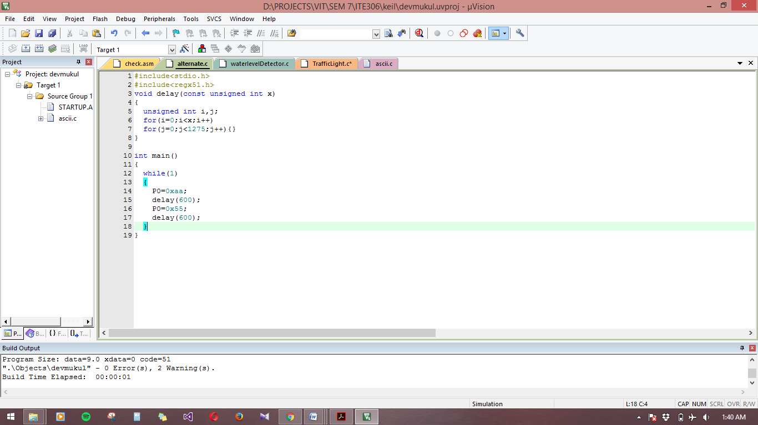

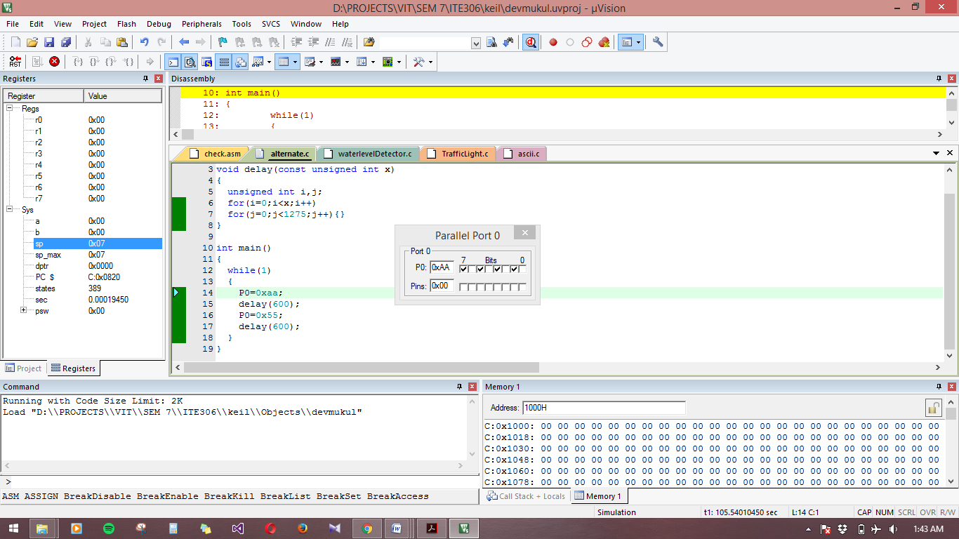

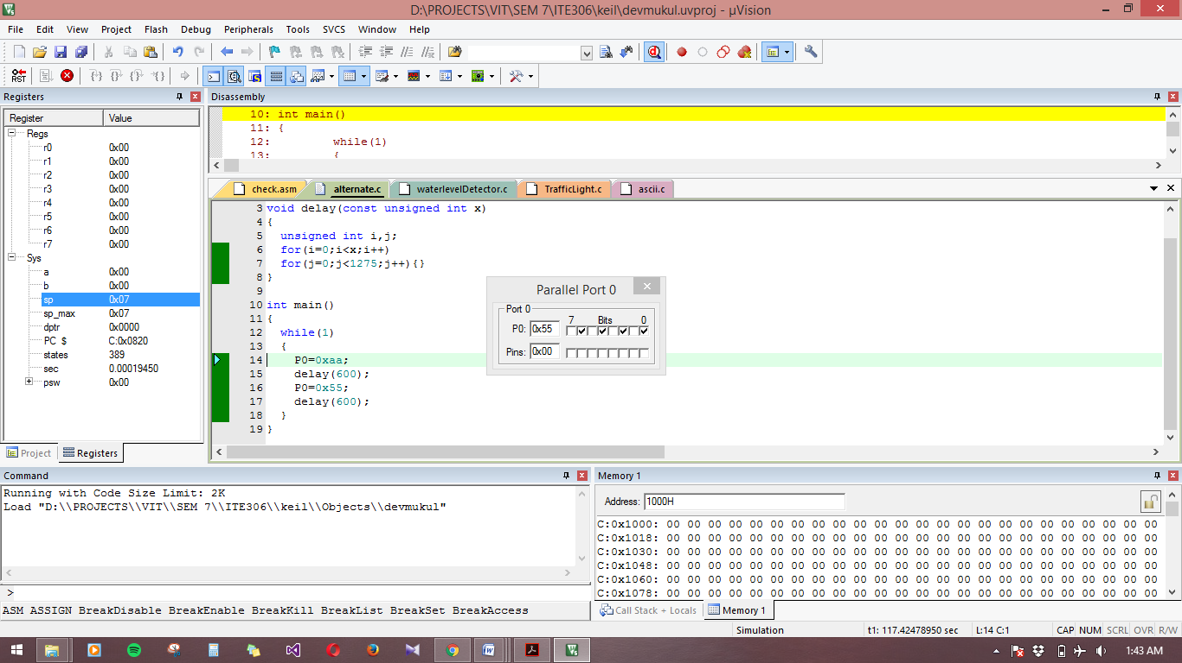

**Embedded C program to implement Water-Level Detector**

#include<regx51.h>

#include<Math.h>

void delay()

{

unsigned int i,j;

for(i=0;i<1000;i++)

for(j=0;j<10000;j++){}

}

int main()

{

unsigned int i;

P1=0x00;

P2=0x00;

for(i=0;i<9;i++)

{

P1=pow(2,i)-1;

delay();

}

if(P1_7==1)

{

P2_0=1;

while(1);

}

}

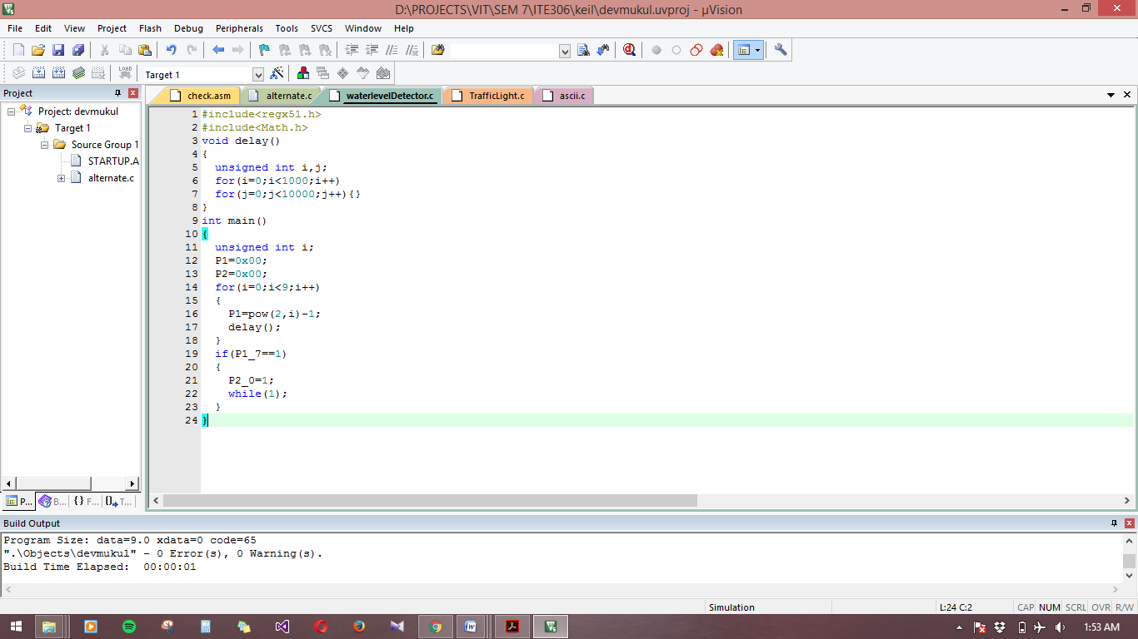

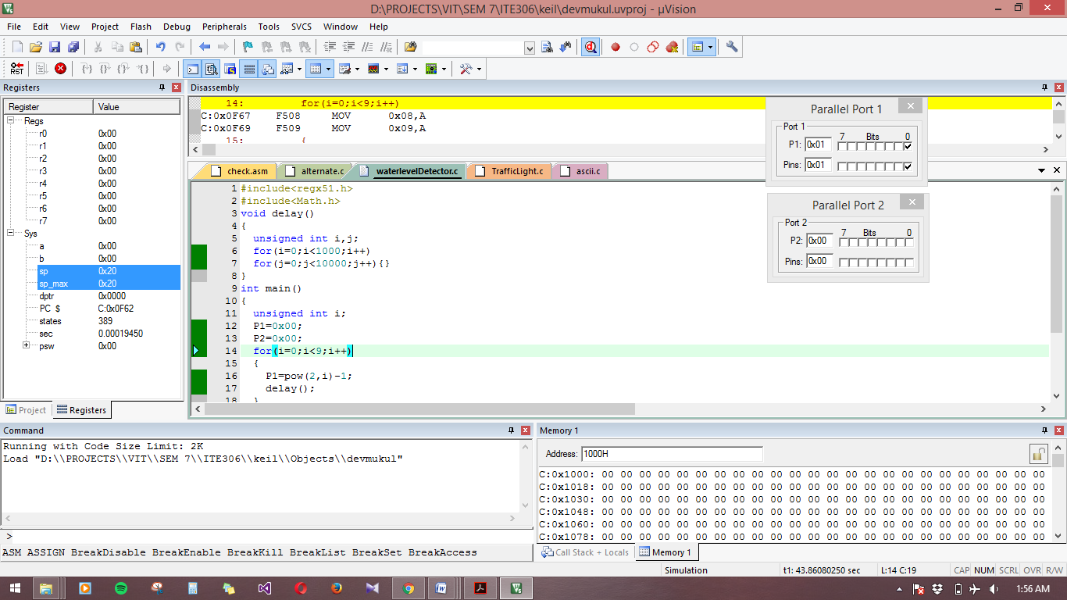

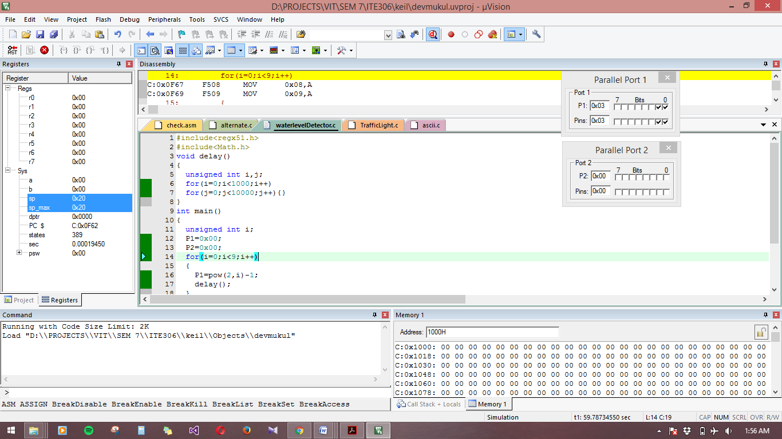

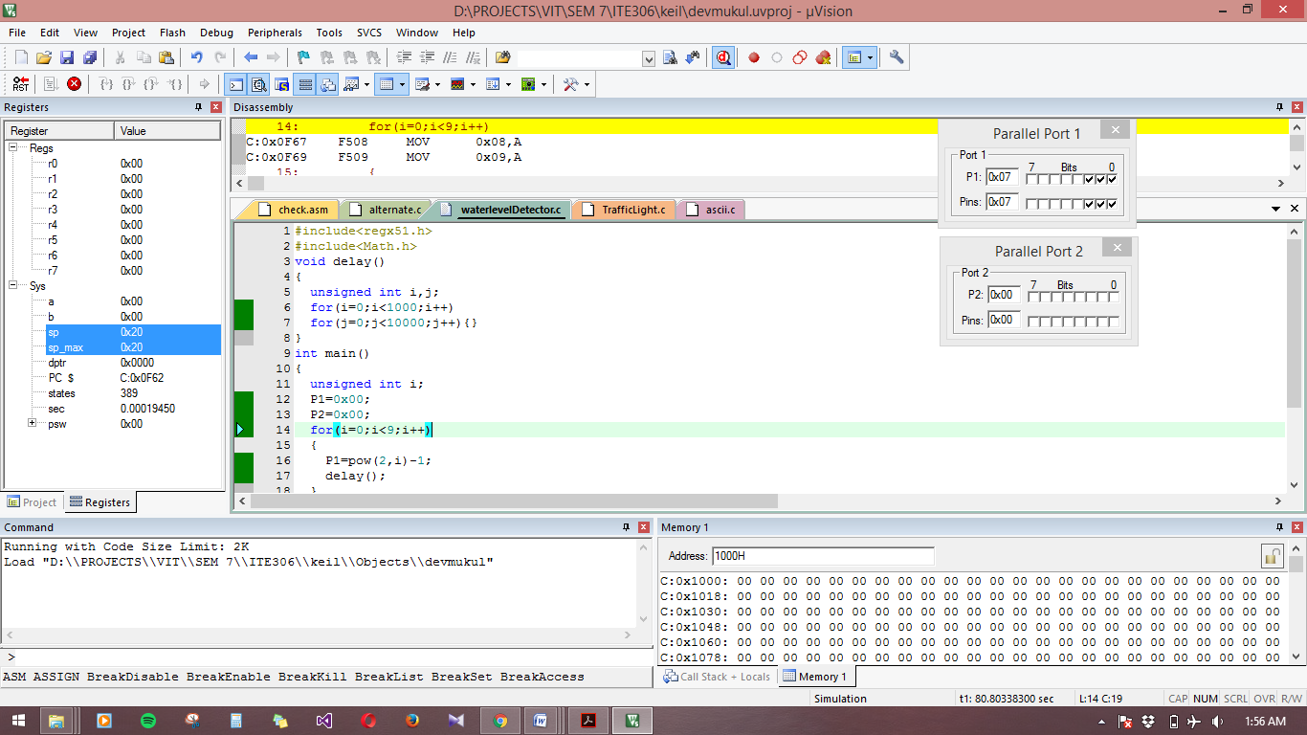

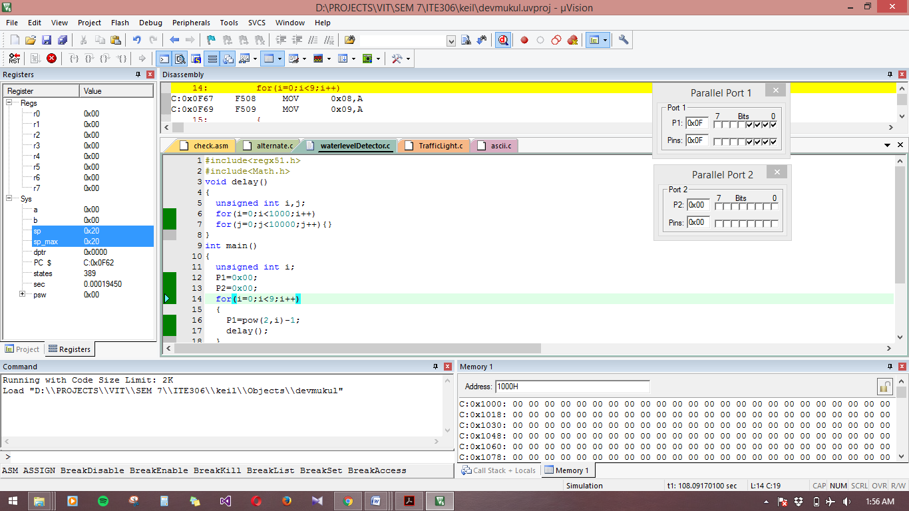

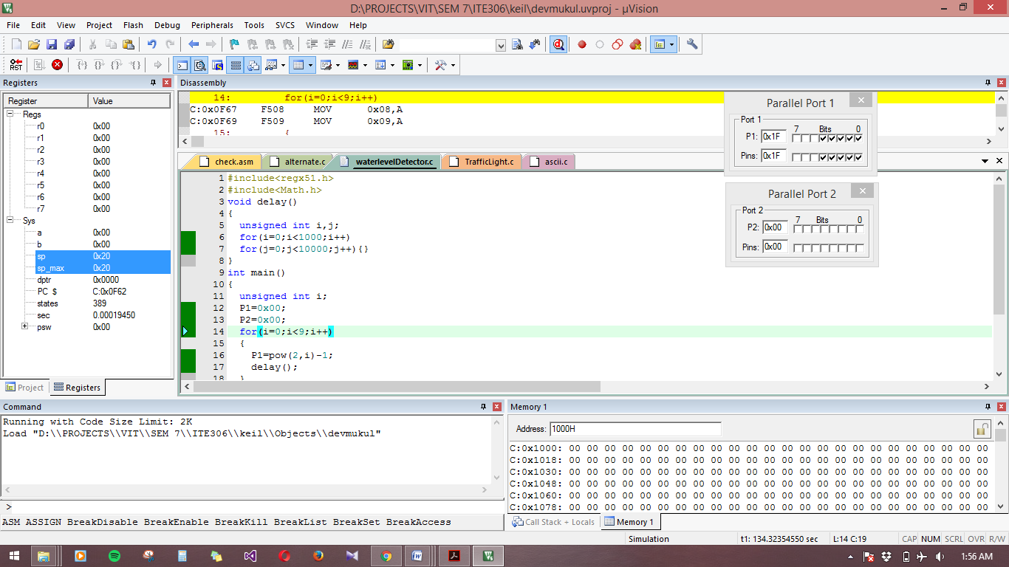

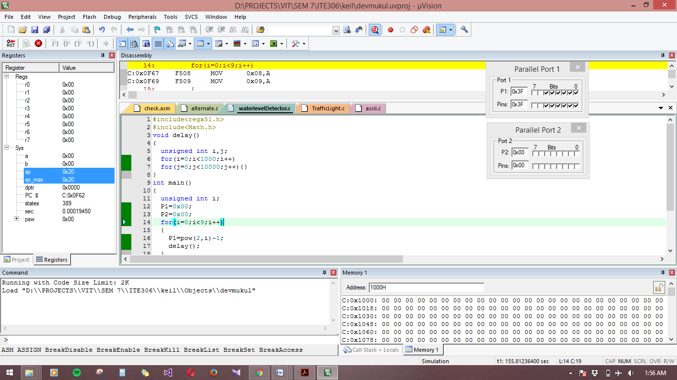

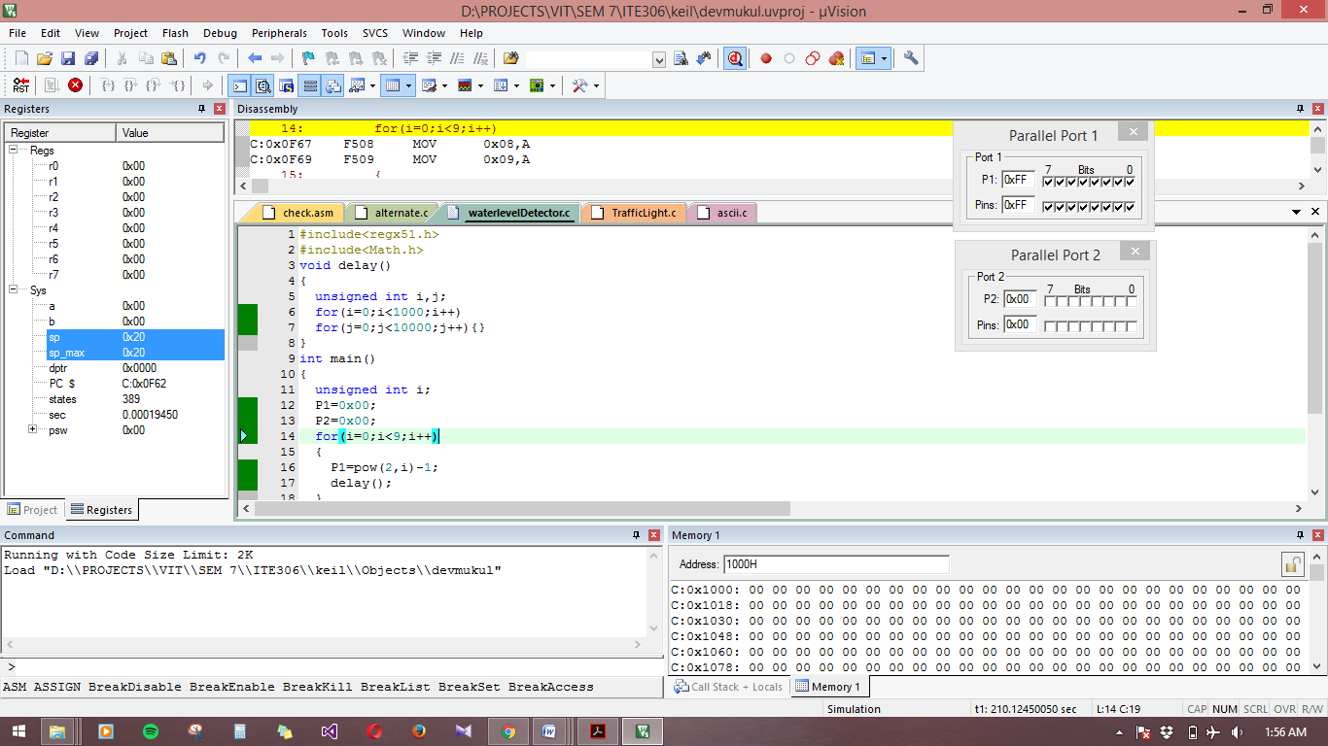

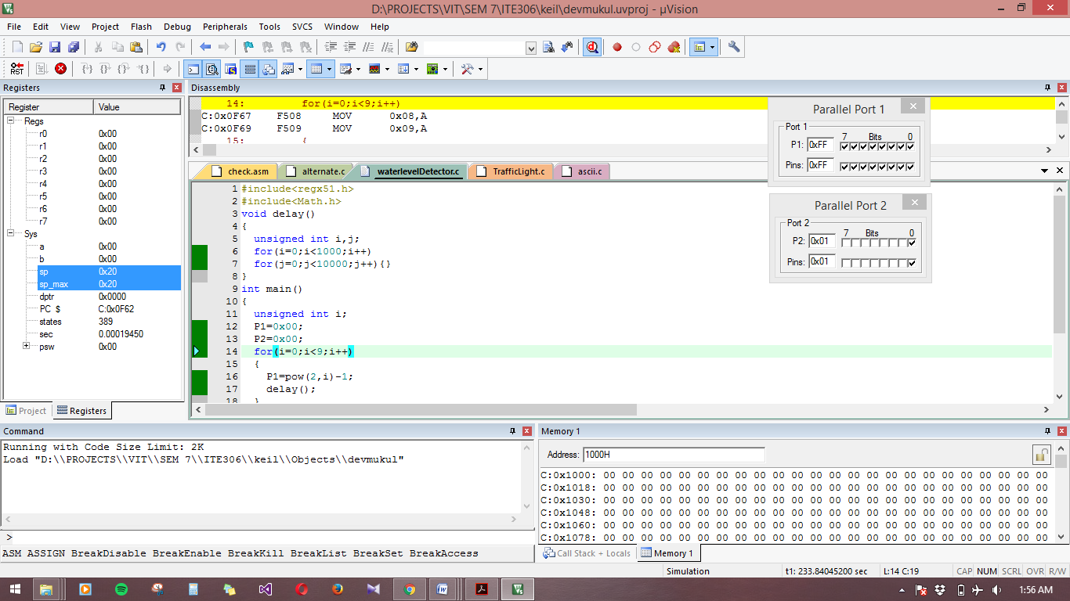

**Embedded C program to implement Traffic Control Signal**

#include<regx51.h>

void delay()

{

unsigned int i,j;

for(i=0;i<1000;i++)

for(j=0;j<10000;j++){}

}

void red()

{

P0_0=1;

P0_4=0;

P0_7=0;

delay();

}

void yellow()

{

P0_0=0;

P0_4=1;

P0_7=0;

delay();

}

void green()

{

P0_0=0;

P0_4=0;

P0_7=1;

delay();

}

int main()

{

P0=0x00;

while(1)

{

red();

yellow();

green();

}

}

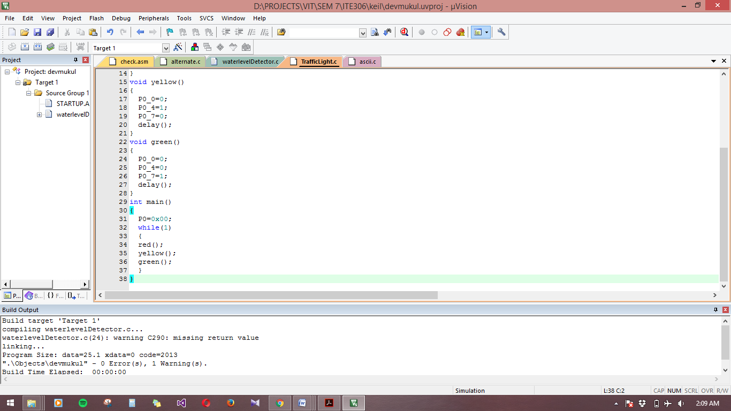

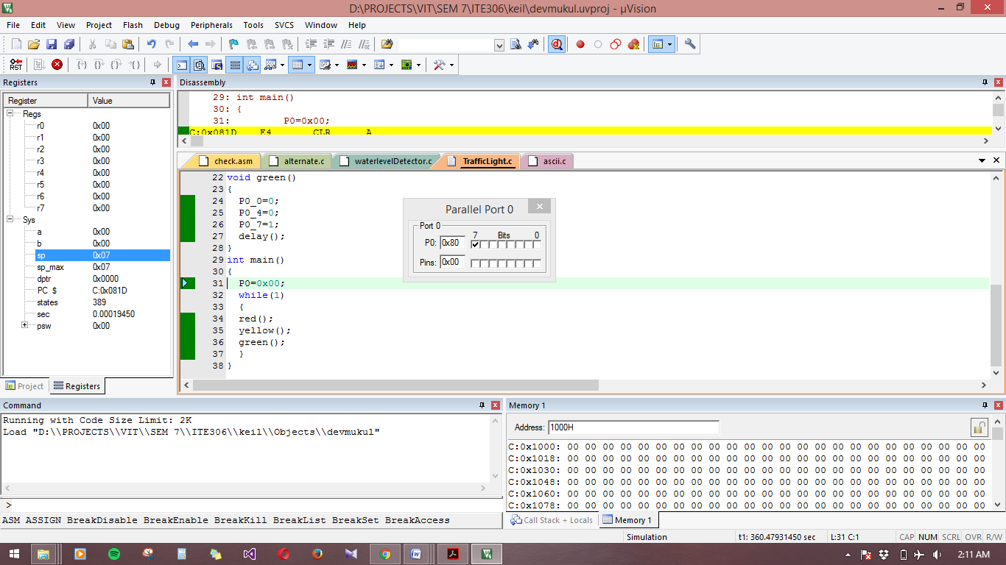

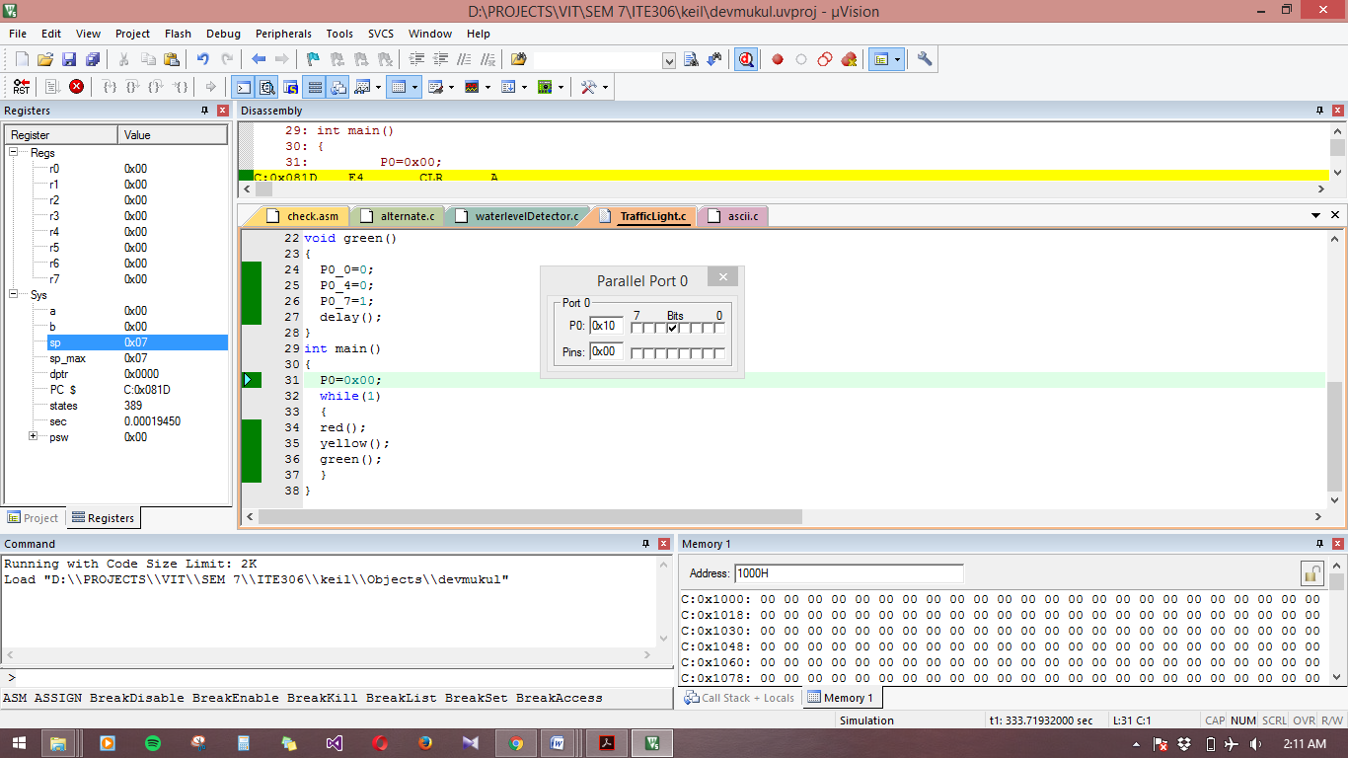

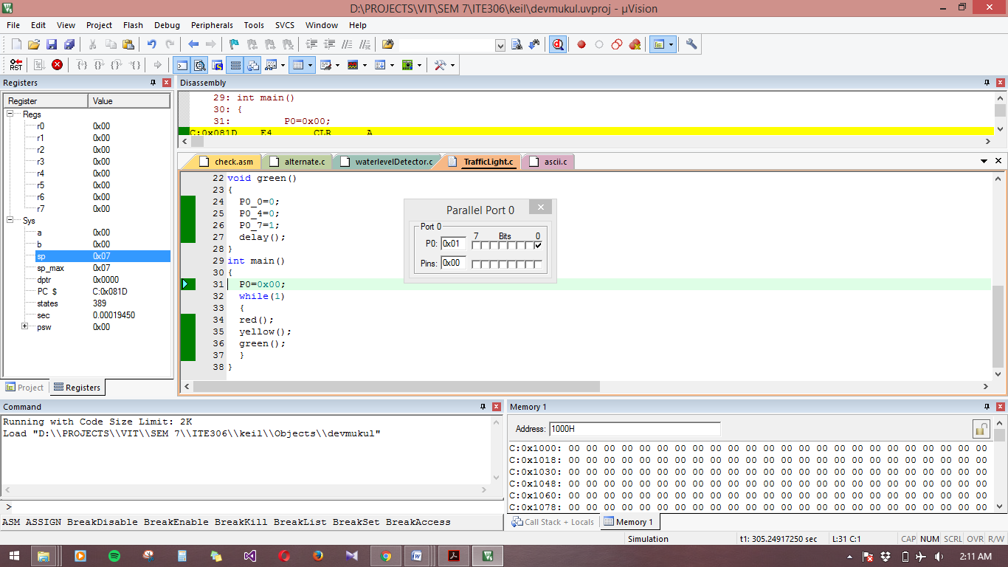

**Embedded C Program to send ASCII value of the characters**

#include<stdio.h>

#include<regx51.h>

void delay(unsigned int x)

{

unsigned int i,j;

for(i=0;i<x;i++)

for(j=0;j<120;j++){}

}

int main()

{

unsigned char x='a';

P2=(int)x;

}

